FunnishaInsights.com – Episode 6
The Email That Changed the Case
When One Ordinary Email Became Extraordinary Transfer Pricing Evidence

The Email Nobody Thought Mattered
“Aarav… I found something.” It was 8:47 PM. The GlobalTech investigation had already consumed two weeks. Contracts had been reviewed. FAR analysis had been completed. Board minutes had been collected. R&D budgets had been examined. The DEMPE analysis was beginning to take shape. Yet something still did not fit. GlobalTech USA was the legal owner of the patent. GlobalTech India had hundreds of engineers. GlobalTech Singapore handled regional licensing. The intercompany agreement stated that the US entity controlled the intellectual property strategy. On paper, everything looked perfectly organised. But the manager was not convinced. He had taught Aarav one rule:
“If the story looks too perfect, look for the evidence that tells you what actually happened.”
Aarav opened his laptop. The email had been forwarded by the GlobalTech India R&D team.
The subject line was surprisingly ordinary: “Project Falcon – Next Phase Approval.”
- Nothing unusual.
- No legal terminology.
- No reference to transfer pricing.
- No mention of DEMPE.
Just an internal business email. Aarav started reading. Then he stopped. He read it again.
And again. The email said that the Indian R&D team had recommended pausing Project Falcon. But that was not the important part.
The important part was this: The Indian team had recommended stopping the project six months earlier and someone in the US had overruled that recommendation.”
Aarav immediately called his manager.
“Sir… I think I found something.”
The manager was silent.
“What?”
“An email relating to Project Falcon.”
“Send it.”
Aarav forwarded it.
Five minutes later, the manager replied:
“Do not draw a conclusion yet.”
Aarav was confused.
“Sir, doesn’t this prove that India was making the key decisions?”
The manager called him.
“No, Aarav.”
“This email does not prove the answer.”
“It tells us where to investigate next.”
That sentence changed the way Aarav looked at evidence.

An email is not automatically powerful evidence merely because it exists.
Its importance depends on:
- Who wrote it?
- Who received it?
- What authority did the sender have?
- What decision was being discussed?
- Was the decision actually implemented?
- Is it consistent with board minutes, budgets and project records?
- Does the actual conduct of the parties support it?

The manager explained:
“Evidence is powerful when different pieces of evidence tell the same story.”

One email can raise a question. Multiple consistent pieces of evidence can help establish the facts.

THE EMAIL TRAIL
The manager asked Aarav to construct an Evidence Trail.
Step 1 — Find the Decision
- What exactly was decided?
Project Falcon was almost cancelled.

Step 2 — Find the Decision-Maker
- Who had authority to stop the project?
Aarav initially assumed the Indian R&D head.
But the email showed something different.

Step 3 — Find the Authority
- Who had the power to approve continuation?
That answer was buried inside the company's governance structure.

Step 4 — Find the Money
- Who approved the additional R&D budget?
The next document revealed that the US parent had approved additional funding.

Step 5 — Find the Conduct
- What happened after approval?
The Indian engineers continued development.

Step 6 — Connect the Evidence
Now the story became more complicated. India was performing significant development work. The US entity was approving major investment decisions. The contract said one thing. The operational evidence showed a more nuanced picture.

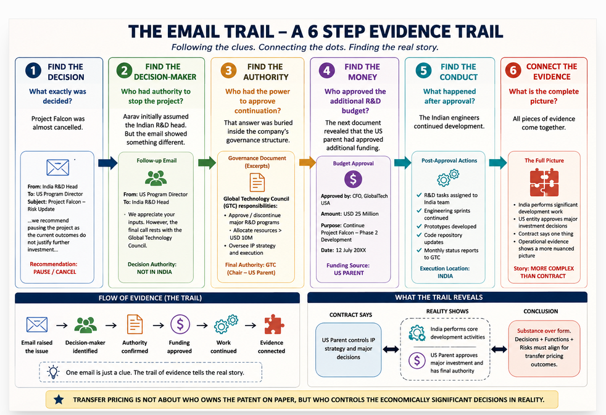

THE “AHA!” MOMENT Aarav looked at the manager. “So, the question isn't simply: Who performed DEMPE?”
The manager smiled. “Exactly.” “The better question is:
Who performed which economically significant activities, who made the relevant decisions, who controlled the associated risks, and what evidence demonstrates that reality?
Aarav suddenly understood why his manager had refused to accept a simple conclusion.
Performance ≠ automatic entitlement.
Funding ≠ automatic entitlement.
Legal ownership ≠ automatic entitlement.
Headcount ≠ automatic entitlement.
The analysis requires the whole picture.
Similarly:
“US owns the patent → US automatically gets all residual return.
THE 5-MINUTE EMAIL TEST The manager gave Aarav a challenge. “Imagine you have only five minutes to review this email.” “What would you look for?” Aarav opened his notebook.
The manager dictated:
1. Decision: What decision is actually being made?
2. Authority: Who has the authority to make it?
3. Consequence: What happens if the decision goes wrong?
4. Evidence: What other documents support the email?
5. Consistency: Does the actual conduct match the contractual story?

The manager closed the file. “Never read an email only for what it says. Read it for what it reveals.”
A transfer pricing investigation does not necessarily begin with a complicated tax document.
Sometimes the most useful evidence may be hidden in ordinary business records:

- Emails.
- Budget approvals.
- Meeting minutes.
- Project documents.
- Internal presentations.
- Governance records.
- Decision logs.
The OECD Guidelines specifically recognise that written contracts alone may not contain everything needed for a transfer pricing analysis and that evidence of actual conduct can clarify or supplement the contractual picture.
That is why the best consultants don't simply ask: “What does the agreement say?”
They ask: “What actually happened?”
BUT THEN…
Just when Aarav thought he had solved the mystery, another email appeared.
This one was from the CEO.
Subject: “Why did India initiate or authorise the patent filing?”
Aarav froze. India had apparently authorised a patent filing. But the agreement said the US parent controlled the global patent strategy. The manager looked at Aarav. “Now we have a problem.”
“Tomorrow, we investigate who really controlled the IP strategy.” Aarav closed his laptop.
But one question stayed in his mind: If the contract says the US controls the IP strategy, why was India involved in approving or initiating the patent filing?
The Decision Nobody Could Explain The second email may be even more important than the first. Because this time, Aarav discovers something far more dangerous than a contradiction. A decision trail that does not match the organisational chart and that leads to the next question: Who really controlled the economically significant decisions?

When the Decision Trail Didn't Match the Organisation Chart “The most dangerous evidence is not the evidence that contradicts the contract. It is the evidence that contradicts the entire story.”

THE NEXT MORNING
Aarav arrived at the office earlier than usual. The previous evening's email was still open on his screen.
Project Falcon – Risk Update
The Indian R&D team had recommended pausing the project. Yet the project continued. Someone had overruled the recommendation.
The question was simple: Who?
Aarav opened the organisation chart.
At first glance, the answer seemed obvious.
GlobalTech USA
↓
Global Technology Council
↓
GlobalTech India R&D
The structure appeared clear.
But the manager had taught him not to confuse a reporting line with a decision-making line. “Open the decision records,” the manager said. Aarav began searching.

CLUE NO. 1 — THE ORGANISATION CHART
The chart showed that the Indian R&D Head reported to the Global Technology Council. But reporting to someone does not necessarily mean that every decision is made by that person.
The manager asked: “Who could actually approve the decision?” Aarav checked the governance documents. The answer surprised him.
The Indian R&D Head could:
- recommend technical changes;
- manage the engineering team;
- prepare project assessments;
- recommend continuation or suspension.
But the authority to approve major strategic decisions rested elsewhere. The organisation chart had shown who reported to whom. It had not shown who had the authority to make the economically significant decision. Aarav wrote one sentence in his notebook:

Reporting line ≠ Decision authority

“A reporting line does not, by itself, establish who controls an economically significant decision.”

CLUE NO. 2 — THE SECOND EMAIL
Then Aarav found another email. This one was sent by the US Program Director.
The subject line read: “Project Falcon — Final Direction”
The email was short. “We have reviewed the technical recommendation. Project Falcon will continue to Phase 2. Please proceed with the revised development plan.”
Aarav stopped.
The Indian R&D team had recommended pausing the project. The US Program Director had instructed the team to continue. But there was another question. Did the US Program Director actually have the authority?
The manager nodded.
“Good.”
“Now you're asking the right question.”

CLUE NO. 3 — FOLLOW THE AUTHORITY
Aarav traced the approval chain. The decision eventually led to the Global Technology Council. The Council had authority over major R&D programmes and strategic technology decisions. The US Program Director could communicate the decision. But the underlying governance authority came from the Council. This was becoming more interesting.
Aarav realised something important:

The person communicating a decision is not necessarily the person controlling the decision. That distinction can completely change an investigation.

CLUE NO. 4 — FOLLOW THE MONEY
The manager gave Aarav another instruction: “Now forget the emails. Follow the money.”
Aarav opened the budget records. Project Falcon had originally been approved with a substantial R&D budget. After the Indian team recommended pausing the project, additional funding was approved. The approval came from the US parent. The project received funding for another development phase. Aarav looked at the documents. India was doing the development. The US parent was approving significant funding. The Global Technology Council was exercising strategic authority. The funding approval was an important piece of evidence, but funding alone did not establish control of the relevant risk. The contract still described the US parent as controlling the IP strategy. Suddenly, the story was no longer black and white.

THE MANAGER'S QUESTION
The manager drew three circles on the board:

FUNCTIONS
Who performed the work?

CONTROL
Who made the economically significant decisions?

RISK
Who actually controlled the relevant risks and had the financial capacity to assume them?
The funding approval was an important piece of evidence, but funding alone did not establish control of the relevant risk.
Then he connected the circles.
“Aarav, this is why transfer pricing investigations are rarely solved by one document.”
“Under the OECD Transfer Pricing Guidelines, accurate delineation of the transaction requires consideration of the written contractual terms together with the conduct of the parties and economically relevant characteristics.”

THE SHOCKING DISCOVERY
Aarav thought the investigation was almost complete. Then he found a document buried in the project folder. “Falcon Steering Committee — Emergency Meeting”
Date: 18 July
Participants:
- GlobalTech USA
- GlobalTech India
- Global Technology Council
- GlobalTech Singapore
Aarav opened the minutes. The first item was routine. The second item was not. “Decision: Continue Project Falcon despite India R&D recommendation to pause.”
Aarav kept reading. Then he saw the names of the people who voted. The Indian R&D Head had recommended pausing the project. The Global Technology Council had approved continuation.
The US parent had approved additional funding and Singapore had been asked to assess the commercialisation strategy.
Aarav leaned back. The pieces were finally connecting.

THE EVIDENCE MATRIX
The manager asked Aarav to put everything into one table.
Question | Evidence
Who performed development? | India R&D team
Who recommended pausing? | India R&D Head
Who approved continuation? | Global Technology Council
Who approved additional funding? | US parent
Who continued development? | India R&D
Who handled commercialisation? | Singapore
Who legally owned the IP? | US parent
Who controlled the relevant risk? | Investigation continues
Aarav looked at the table. “No single entity appears to have done everything.”
The manager smiled.

“Exactly.”

THE BIGGEST LESSON
This is where many inexperienced analyses can go wrong. They search for one winner.
One entity that:
- developed the IP;
- controlled the risk;
- funded the project;
- owned the patent;
- commercialised the product.
But multinational businesses do not always operate that way.
- Different entities can perform different economically significant activities.
- Different people can make different decisions.
- Different entities can contribute at different stages.
Therefore, the real question is not: “Which country gets the IP profit?”
The real investigation begins with: “What did each party actually do, what decisions did it control, what risks did it control, and what evidence supports those conclusions?”
That is much closer to the way the OECD framework approaches accurate delineation of controlled transactions.

THE THREE-DOCUMENT TEST
The manager gave Aarav one final professional shortcut.
Whenever he sees an important contractual claim, he should search for three things:

1. CONTRACT
What does the agreement say?
↓

2. GOVERNANCE
Who was actually authorised to decide?
↓

3. CONDUCT
What did the people actually do?
Then ask: Do all three tell the same story?
If YES → the position may be more internally consistent.
If NO → investigate further.
A contradiction does not automatically prove a transfer pricing error. But it is a signal that the analysis needs deeper examination.
THE “CONTROL” TRAP
Aarav suddenly asked: “Sir, then is the person who performs the work more important than the person who controls the decision?”
The manager smiled. “Don't fall into another trap.”
“Neither job title nor headcount alone answers the question.”
“The engineer may perform critical technical work.”
“The executive may approve the budget.”
“The board may approve the strategic direction.”
“The IP owner may hold the legal rights.”
“And another entity may commercialise the resulting intangible.”

“Your job is not to choose one document.”

“Your job is to reconstruct the business reality.”

THE FINAL PIECE
Aarav thought he had finally solved Project Falcon. Then he noticed something unusual.
The same executive's name appeared on:
- the R&D approval;
- the additional funding approval;
- the patent strategy meeting;
- the commercialisation meeting.
Aarav stared at the screen. The executive was formally based in Singapore.
But the organisation chart showed that the executive had no direct responsibility for GlobalTech India's R&D function. Why was the same person appearing across so many critical decisions?
Aarav turned to the manager. “Sir…”
The manager looked up. “What did you find?”
Aarav pointed to the name. “I think our decision-maker may not be where the organisation chart says he is.”
Silence. The manager closed the file. Then he said: “Now we have a real investigation.”

THE CONSULTANT'S NOTEBOOK
Aarav wrote down five questions.

1. Who had authority?
Not merely who participated.

2. Who actually made the decision?
Not merely who signed the document.

3. Who controlled the relevant risk?
Not merely who was named in the contract.

4. Who had the financial capacity to assume that risk?
Not merely who funded the project.

5. What contemporaneous evidence supports the conclusion?
Not merely what the company says today.

THE BIG REVEAL
The manager placed the patent certificate on one side of the table. The organisation chart in the middle and the decision records on the other side.
He looked at Aarav. “Which document tells you, Who actually controlled the economically significant decisions relating to the IP?”
Aarav paused. This time, he did not answer immediately.
He looked at all three. Then he said: “None of them alone.”
Patent certificate ≠ complete TP analysis
Organisation chart ≠ complete TP analysis
Contract ≠ complete TP analysis

The manager smiled. “Now you're thinking like a transfer pricing consultant.”

THE REAL TAKEAWAY

Contract tells you the intended arrangement. Governance tells you the formal authority. Conduct tells you what actually happened. Evidence connects the three.
And that is why: A strong transfer pricing analysis is not a document-reading exercise. It is a reconstruction of economic reality.
The OECD Guidelines expressly recognise that contractual arrangements should be considered alongside actual conduct when accurately delineating the transaction.

BUT AARAV HAD ONE LAST QUESTION… “If the same executive was influencing decisions across the US, India and Singapore…” “Who was actually controlling the risk?”
The manager smiled. He opened a new folder.
The title was: “PROJECT FALCON — RISK REGISTER”
Aarav opened the first page and immediately saw something that changed the entire investigation.

**The party named in the contract as assuming the risk… …may not have been the party actually controlling that risk.**
TO BE CONTINUED…

EPISODE 7 — COMING NEXT

WHO REALLY CONTROLLED THE RISK? Aarav thought he was investigating IP ownership.
Then he discovered he was actually investigating risk control and the next question became even more uncomfortable:
If the contract assigns a risk to one entity, but another entity actually controls that risk, where should the associated return be analysed?
Episode 7 — Risk, Control & the Money Trail
Coming next on FunnishaInsights.com

